ReactJS Hands-on 14 - React Context API (Employees App)

Commands Used
- npm install
- npm start

Project Structure

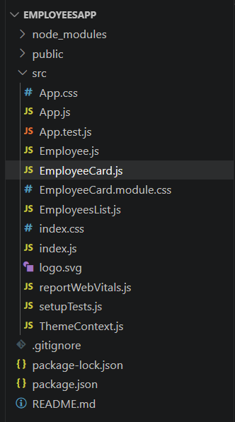

ThemeContext.js
import { createContext } from 'react';
const ThemeContext=createContext('light');
export default ThemeContext;

App.js
import './App.css';
import { EmployeesData } from './Employee';
import EmployeesList from './EmployeesList';
import { useState } from 'react';
import ThemeContext from './ThemeContext';
function App(){
const Employees=EmployeesData;
const [theme,setTheme]=useState('light');
return(
<ThemeContext.Provider value={theme}>
<div>
<label>SELECT A THEME </label>
<select onChange={(e)=>setTheme(e.target.value)}>
<option value='light'>Light</option>
<option value='dark'>Dark</option>
</select>
</div>
<EmployeesList employees={Employees}/>
</ThemeContext.Provider>
);
}
export default App;

EmployeesList.js
import EmployeeCard from './EmployeeCard';
function EmployeesList(props){
return(
<div>
<h1>Employees List</h1>
{props.employees.map(employee=>(
<EmployeeCard employee={employee} key={employee.id}/>
))}
</div>
);
}
export default EmployeesList;

EmployeeCard.js
import {useContext} from 'react';
import Styles from './EmployeeCard.module.css';
import ThemeContext from './ThemeContext';
function EmployeeCard(props){
const theme=useContext(ThemeContext);
return(
<div className={Styles.Card}>
<h3>{props.employee.name}</h3>
<p>{props.employee.email}</p>
<p>{props.employee.phone}</p>
<p>
<a href="#" className={theme}>Edit</a>{" "}
<a href="#" className={theme}>Delete</a>
</p>
</div>);
}
export default EmployeeCard;

Employee.js
class Employee{
constructor(id,name,email,phone){
this.id=id; this.name=name; this.email=email; this.phone=phone;
}
}
const EmployeesData=[
new Employee(101,'Jojo','jojo@congizant.com','98238971234'),
new Employee(102,'Sam','sam@congizant.com','9981184126'),
new Employee(103,'Elisa','elisa@cognizant.com','9989389735')
];
export default Employee;
export {EmployeesData};

Output
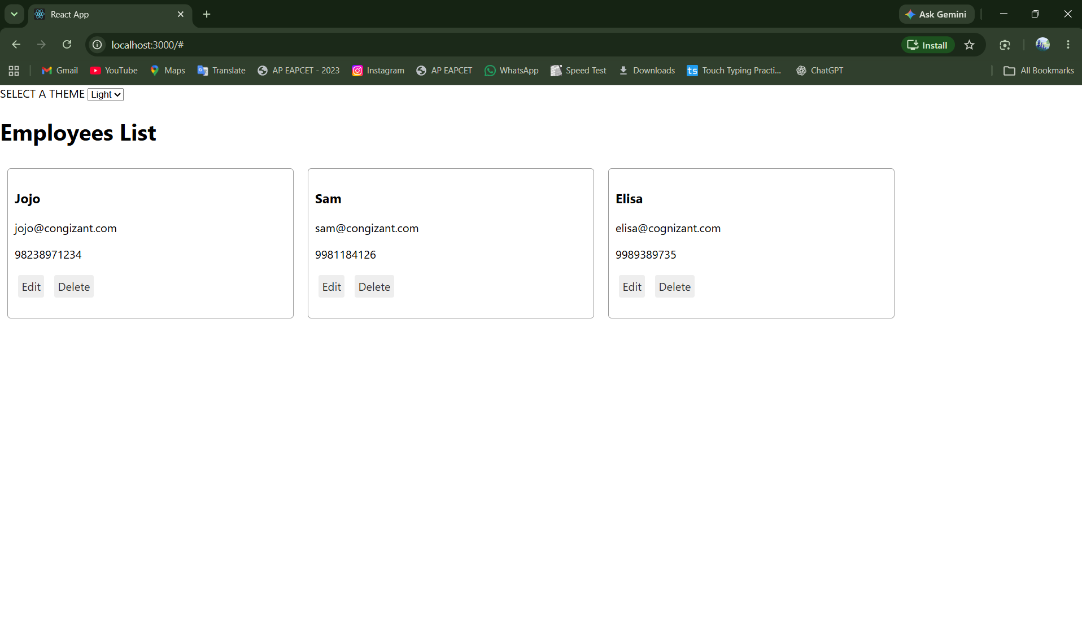
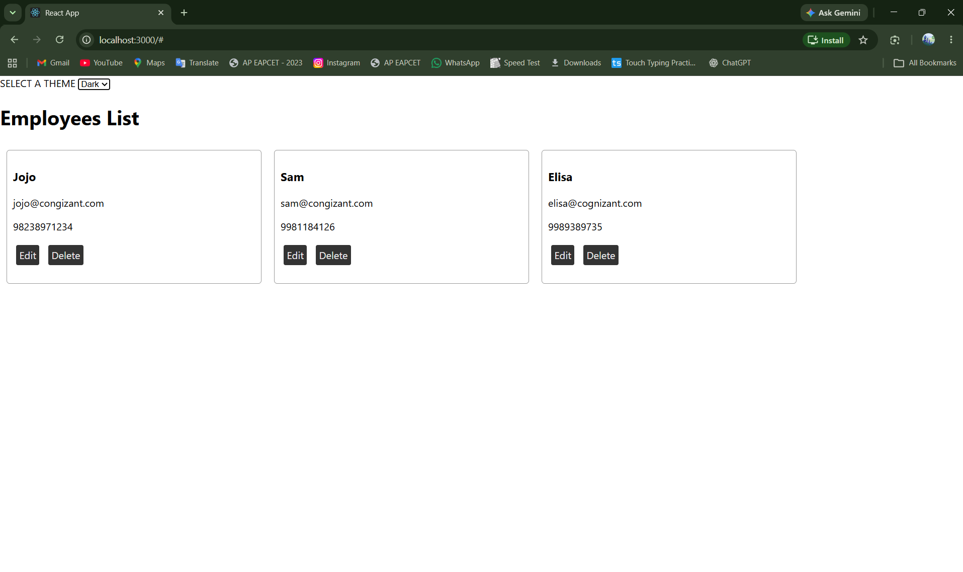

Conclusion
The application successfully demonstrates the React Context API by sharing the selected theme across components without prop drilling.

